• Activity: • As a best practice you need to clean up the workspace before running a new task. • Steps: • Go to configure in PetClinicTest job. • Enable “Delete workspace before build starts” in “Build environment”. • Workspace could be accessed at /var/lib/Jenkins/workspace/PetClinicTest

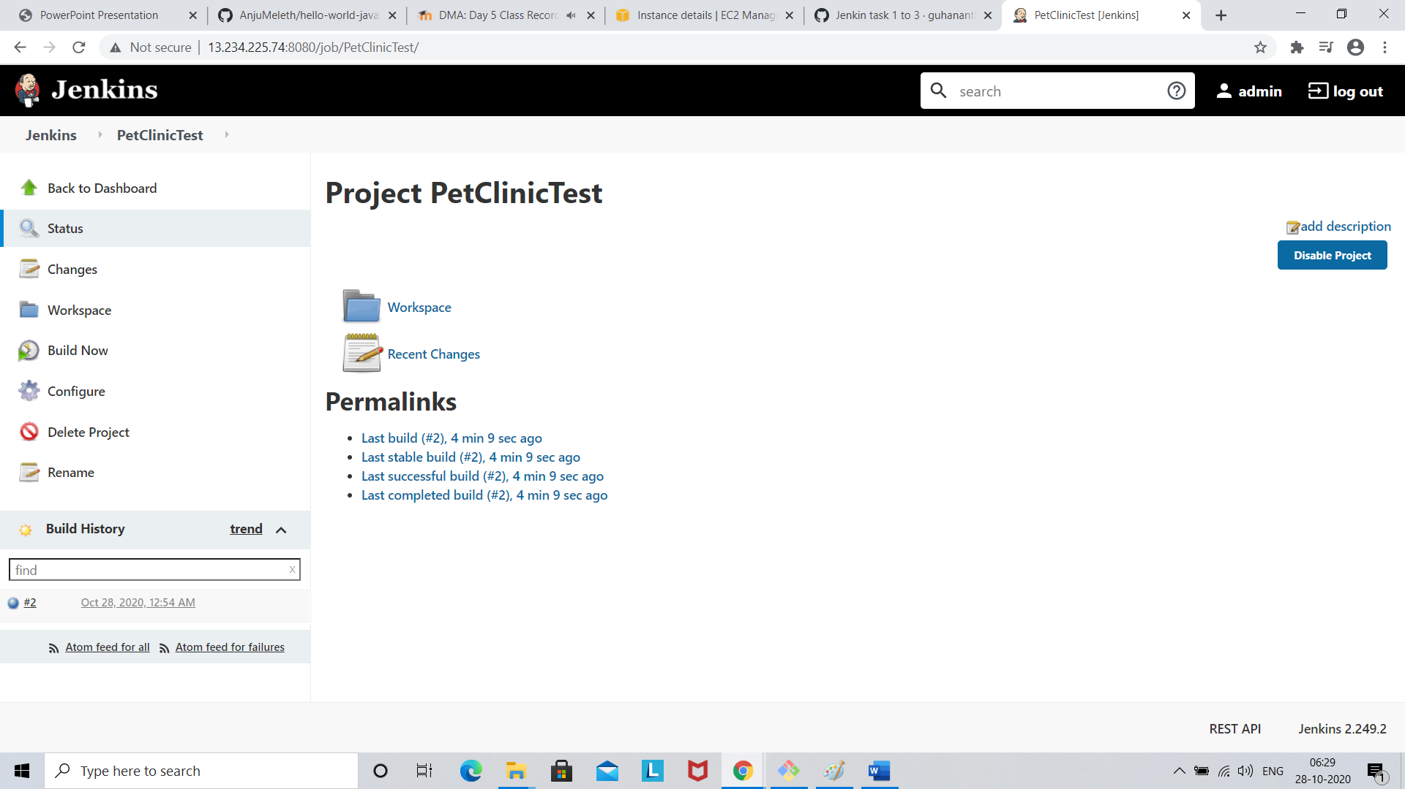

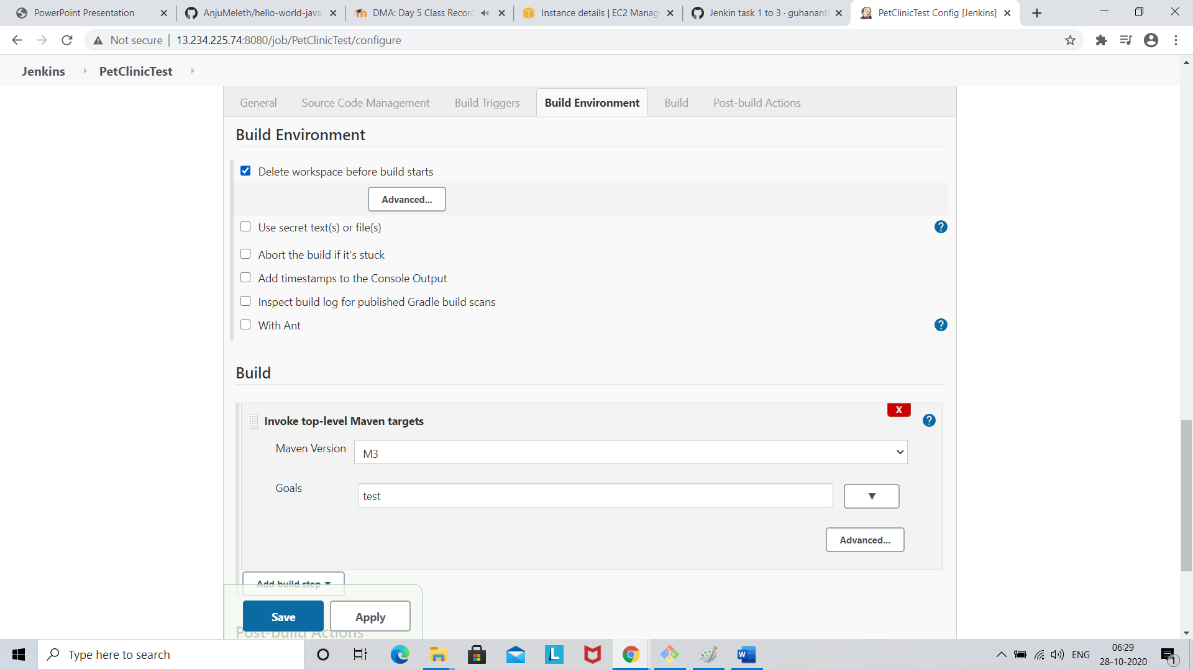

Click save